Activity 2: UML Diagram Design Project

Project Title:
"Online Shopping System"

Objective:
Students will apply their knowledge of UML by designing a system and representing it using appropriate UML diagrams.

System Description:
The Online Shopping System allows customers to view available products, place orders, and track their purchase status. The admin is responsible for managing products, processing customer orders, and tracking expenses. Customers can register, log in, and access items for purchase. Admins can monitor the order flow, update inventory, and maintain financial records for the store.

Actors/Users:
1. Admin: Manages items, processes orders, records expenses, views customer orders.
2. Customer: Browses available items, places orders, views order history.

Main System Functions:
1. Customer Side:
- Browse available products.
- Place orders.
- View order status.
2. Admin Side:
- Add, update, or remove products.
- View customer orders and manage their status.
- Record expenses related to operations.

UML Diagram Type:
Class Diagram: This will show the structure of the system with key classes like User, Admin, Customer, Item, Order, Expense.
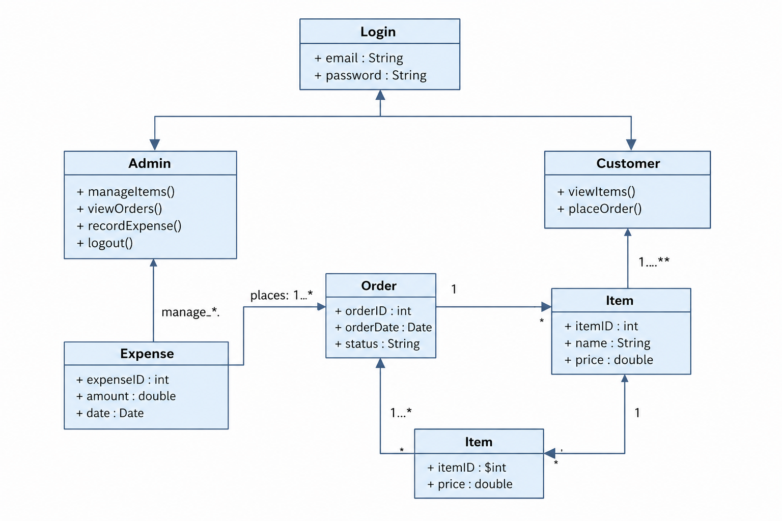
Explanation: This UML class diagram represents an Online Store system with three main classes: Admin, Customer, and Order. The Admin manages items, views orders, and records expenses, while the Customer can view items and place orders. Orders are linked to Items, representing the products purchased, and each Order has its own status and date. The Expense class tracks administrative costs associated with the store operations. The relationships between these classes enable efficient management of inventory, customer orders, and financial tracking.

